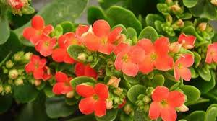

Scientific name: Kalanchoe pinnata

LIGHT:

The Kalanchoe pinnata plant loves the sun.Place your succulent in lightly shaded locations to protect them from harsh sunlight during the day. If you keep them indoors, opt for window sills that receive plenty of light throughout the day.

WATERING:

You need to be careful while watering the Kalanchoe pinnata plant. They are a drought-resistant plant species.Always let the soil dry out completely before watering again.

SOIL:

Any soil mix meant for succulents will work great for the Kalanchoe pinnata plant. Succulent soil mixes have good draining power, which is exactly what these plants need since they are prone to overwatering.

FERTILIZING:

The Kalanchoe pinnata plant does not need fertilizer. It is a hardy plant and does well with the nutrients already present in the soil.

CLIMATE:

The Kalanchoe pinnata plant thrives in warm climates. They love the sunlight and bloom during the summer.

They can survive cold temperatures during the winter, but ideally, the temperature should not drop below 55 degrees Fahrenheit. If you live in an area with extremely cold winters, you need to move your plant indoors to prevent them from freezing.